Design and Development of EMG Based
Robotic Hand for Stroke Recovery

By

Muhammad Ajmal

Final Project Report

Internship Project

Pak-Austria Fachhochschule:
Institute of Applied Sciences and
Technology


Design and Development of EMG Based Robotic Hand for Stroke Recovery

Internship Project

By
Muhammad Ajmal

ABSTRACT

Stroke is the major cause of permanent disability worldwide, with more than 15 million people suffering from stroke and about one-third permanent loss of motor function every year, especially in upper limb functionality. Traditional rehabilitation treatments are frequently time-consuming, repetitive, and require constant therapeutic observation. This thesis focuses on the design and development of a cost-effective, non-invasive robotic hand system intended to assist stroke patients in regaining hand function through rehabilitation. To support the recovery process, this project introduces a glove that combines soft robotics with real-time muscle activity monitoring. The system is composed of two main functional modules. The first is a soft robotic glove, which uses flexible pneumatic actuators to assist finger movements. These actuators are controlled through miniature air pumps and 3-port solenoid valves, allowing controlled inflation and deflation that mimic natural hand motion. The glove is made from soft, adaptable materials such as silicone or TPU, ensuring comfort and safety for the user.
The second module includes an Electromyography (EMG) sensor system that detects electrical activity generated by forearm muscles. Surface EMG electrodes are used to capture signals that are sent to a microcontroller to evaluate muscle strength. Muscle strength levels are also displayed on an LCD screen in real time. The system is designed to be affordable and easy to use, making it suitable for home-based therapy in addition to clinical environments. By integrating soft pneumatic actuation with EMG-based muscle strength monitoring, the glove promotes muscle engagement and neural reactivation, which are critical for restoring motor functions after a stroke. Overall, this robotic hand offers a promising approach to stroke rehabilitation by enabling repetitive, guided hand movements in a safe, user-friendly, and cost-effective manner.
Table of Contents

Introduction 1
1.1. Background 2
1.2. Motivation 2
1.3. Problem Statement 3
1.4. Objectives of the Study 5
1.5. Scope pf the Project 6
1.6. Significance of Study 6
1.6.1. Rehabilitation results everywhere improved 6
1.6.2. User-centered Design 7
1.6.3. Technological Innovation 7
1.7. Methodology Overview 7
1.7.1. Literature Review and Research Analysis 7
1.7.2. System Design 7
1.7.3. Hardware development 8
1.7.4. Software Development 8
1.7.5. Integration and Testing 8
1.8. Expected Results 9
1.8.1. Functional EMG-Controlled Robotic Hand Prototype 9
1.8.2. User Interface or Visual Feedback System 9
1.8.3. System Performance Metrics 9
1.9. Challenges and Limitations 10
1.9.1. Mechanical design constraints 10
1.9.2. User Testing 10
Literature Review 11
2.1. Introduction 12
2.2. EMG Base Devices 12
2.3. Robotic Rehabilitation Systems 13
2.4. Signal Acquisition and Processing Techniques 14
2.4.1. Signal Acquisition 14
2.4.2. Processing Techniques 14
2.5. Actuation Mechanisms 14
2.6. Commercial and Open-Source Solutions 16
2.6.1. Commercial Systems 17
2.6.2. Open-Source Projects 18
2.7. Identified Gaps and Relevance to This Project 19
2.8. Summary and Gap Identification 20
2.8.1. Cost and Accessibility 20
2.8.2. Customizability and Open Adaptation 20
2.8.3. Pneumatic Actuation 21
2.8.4. Lack of Arduino-Based, Portable Solutions 21
2.8.5. Project Novelty and Relevance 21
System Design and Methodology 23
3.1. Introduction 24
3.2. System Architecture Overview 24
3.3. Design Methodology 27
3.3.1. Requirement Analysis 27
3.3.2. Soft Robotic Glove Module 27
3.4. Working 28
3.4.1. Material and Structural Design 29
3.4.2. Pneumatic System 29
3.4.3. Actuation Logic 30
3.5. Control Strategy 30
3.6. Summary 31
Implementation & Testing 32
4.1. Introduction 33
4.2. Implementation of the Soft Robotic Glove Module 33
4.2.1. Pneumatic System Setup 33
4.2.2. Individual Finger Control 34
4.3. Implementation of the EMG Sensor Module 34
4.3.1. EMG Sensor 34
4.3.2. A microcontroller (Arduino) 35
4.3.3. LCD Display 35
4.3.4. Module's Operation 35
4.4. Integration of Both Modules 36
4.4.1. System Integration 36
4.4.2. Connecting Muscle Signals to Glove Movement 36
4.4.3. Making the System Move in Sync with Muscle Activity 37
4.4.4. Displaying Feedback for the User 37
4.5. Summary 38
Results and Discussion 39
5.1. Introduction 40
5.2. Performance of the Soft Robotic Glove 40
5.3. Key Observations 41
5.3.1. Comfort and Fit 41
5.3.2. Ease of Use: 41
5.3.3. Responsive Actuation: 41
5.4. EMG Signal Aquisition 42
5.5. Control Strategy Evaluation 42
5.6. User Feedback and Comfort 43
5.7. Discussion of Limitations 43
5.8. Summary 44
Conclusion and Future Work 45
6.1. Conclusion 46
6.2. Project Limitations 47
6.2.1. Probability 47
6.2.2. Limited Range of Motion 47
6.2.3. Basic EMG Signal Processing 48
6.3. Future Work 48
6.3.1. Miniaturization and Enhanced Portability 48
6.3.2. Precise Control for Fingers 49
6.3.3. Future Enhancements in EMG Signal Processing 49
6.3.4. Clinical Testing and Validation 50
6.3.5. User Interface Improvements 50
6.4. Summary 51
6.5. Final Remarks 51
References 52

LIST OF FIGURES

Figure 1: Block Diagram of Actuator .......................................................................... 26 Figure 2: Working of Actuator ..................................................................................... 28 Figure 3: Mini Air Pump Generate the Pressure .......................................................... 29 Figure 4: Solenoid Valve Control the Pressure ............................................................ 30 Figure 5: EMG Sensor Module Kit .............................................................................. 34 Figure 6: Microcontroller Arduino............................................................................... 35 Figure 7: LCD Display the EMG Sensor Value ........................................................... 35 Figure 8: Using EMG Sensor Module ......................................................................... 36
Figure 9: Showing the Value of the EMG Sensor on LCD .......................................... 37

Chapter 1

Introduction

1.1. Background
Stroke is among the most significant causes of disability globally and significant global health issue that disables millions of individuals every year, leading to physical disability that usually lasts for many years. The World Health Organization (WHO) places stroke as the second most common cause of death and the third most common cause of disability. One of the most important consequences of strokes is disruption of voluntary motor control, especially in the upper limbs, with the hand being most impaired because of its complexity and fine motor requirements. This disorder greatly restricts the patient in executing simple daily activities like eating, writing or dressing, which ultimately influences their independence and quality of life.
Rehabilitation of stroke survivors typically involves lengthy, repetitive, and laborious rehabilitation interventions to regain motor function. Conventional physical therapy interventions are dependent on manual exercises performed under the guidance of an experienced therapist. These intervention methods are time-consuming, costly, and psychologically burdensome for patients and caregivers. In addition, there is very few qualified rehabilitation therapists in general, particularly in low- and middle-income countries, creating an enormous gap in coverage and continuity of care.

1.2. Motivation
Following the constraints in conventional stroke rehabilitation, there have been significant attempts to integrate robotic systems into rehabilitation protocols. Robotic rehabilitation has the benefits of repetitive, consistent and measurable movement crucial for effective neuroplasticity and motor rehabilitation. The systems can likely decrease the workload of human therapists, ensure high precision in control of motion, and facilitate prolonged treatment time without exhaustion.
From among many control strategies, electromyography (EMG) has emerged as a useful technique in enabling human-machine interaction. EMG signals, being electrical muscle signals, are the most direct and natural means of capturing the intention of the patient to perform a movement. Such ability is particularly beneficial for individuals who survive stroke with residual muscle function. Active user engagement is enabled by using EMG signals, which is essential in achieving the highest motor recovery through neuroplastic stimulation.
This project seeks to bridge the gap between biological intent and robotic action by building a low-cost EMG-driven robotic hand for stroke rehabilitation. The system under consideration records and processes EMG signals from residual muscle activity to control a robotic hand that mimics the patient's desired movements. This closed-loop interaction not only supports physical movement, but also stimulates the user's nervous system, which facilitates motor relearning and recovery.

1.3. Problem Statement
Despite major advances in rehabilitation technologies, there is still a huge gap in the availability of affordable, user-friendly, and accessible devices specifically designed for stroke rehabilitation. Current commercial robotic rehabilitation devices, although useful in clinical settings, are extremely expensive, with prices that make them inaccessible to the majority of stroke survivors. Such systems, typically designed for applications in hospitals or specialized rehabilitation clinics, are typically bulky, mobile, and require professional supervision. Therefore, they cannot be used in home treatment, limiting their accessibility, especially for patients in rural or low- and middleincome areas who lack access to healthcare resources. Most current robotic rehabilitation systems also do not involve active patient involvement during therapy. This is an important point because studies have indicated that active patient participation in rehabilitation exercises can greatly improve motor recovery. Passive rehabilitation techniques, where the robotic system moves the patient's limbs without them moving, may not be as effective at stimulating neuroplasticity as exercises that require the patient to actively control or contribute to the movement. This lack of interaction can slow progress and reduce the effectiveness of the rehabilitation process.
In practice, stroke survivors are frustrated by the slow and limited nature of their recovery, especially when they cannot see significant improvements in their hand function. Most patients suffer from a lack of motivation, especially when there is no meaningful feedback or interaction during therapy. Furthermore, traditional rehabilitation methods are labor-intensive and involve constant monitoring by healthcare providers, which can be difficult for most people to access, especially in remote or insecure areas. This results in dropouts from rehabilitation programs or partial recovery.
In addition, patients from poor communities face greater difficulties due to the cost of therapy and inadequate access to licensed therapists. For example, in underserved or rural communities, stroke survivors may lack transportation to rehabilitation centers or clinics. This results in patients being completely dependent on caregivers or attempting to rehabilitate themselves with limited facilities, leading to minimal development.
The main problem that this project aims to address is the absence of a cost-effective, portable, and affordable robotic rehabilitation device that can be implemented in clinical settings as well as at home. The emphasis here is on creating a low-cost, wearable robotic hand that is EMG-controlled. EMG, which captures electrical signals generated by muscle activity, can be used as a natural and intuitive interface to operate the robotic device. This technology is particularly suitable for stroke survivors who have some residual muscle function, whether that function is impaired or compromised.
The robotic hand device developed under this project needs to be able to understand the typically weak, noisy, and changing EMG signals of stroke patients, and decode them into accurate, useful robotic movements in real time. Because the muscle activity of stroke patients can vary based on fatigue, muscle tone, and electrode location, the system must have good signal processing algorithms that can suppress noise and clearly recognize the patient’s intended movements. The device must be reliable, ensuring that signals are accurately picked up and responded to without introducing errors or delays that could be distracting to the patient.
Another important factor is the safety, reliability, and comfort of the device for longterm wear. Stroke survivors may find wearing medical devices uncomfortable or tiring, especially if the devices are heavy or poorly designed. Thus, the robotic hand should be lightweight, ergonomically designed, and made of materials that can be worn for long periods of time without irritation or pain. In addition, the machine should be easy to use so that people with paralysis can practice rehabilitation routines on their own, without the constant guidance of specialists. In this way, they can be able to conduct treatment sessions at home, making it easier for caregivers, and offering 24-hour motor recovery support.

1.4. Objectives of the Study
This study aims primarily to create and put into practice an EMG-based robotic hand model meant specifically for stroke patient rehabilitation.
The general goals are as follows:
EMG signal collecting techniques specifically for stroke victims. One should look for the most efficient techniques of noting low muscle activity and minimizing noise and artifacts which could compromise signal clarity and reliability. To guarantee the subsequent stages in signal processing and control are carried out as intended, precise signal acquisition is critical.
This module consists of a wearable soft robotic glove integrated with flexible pneumatic actuators, such as air bladders or chambers, designed to assist with finger movements. These actuators enable the glove to mimic the natural flexion and extension of the fingers, providing mechanical support during rehabilitation exercises. The actuation system is powered by miniature air pumps that control the inflation and deflation of the actuators, generating the necessary pressure to move the fingers gently and safely. To direct the airflow precisely to individual finger sections, the system utilizes 3-port solenoid valves. These valves regulate the airflow pathway, allowing for selective control of each actuator, which enhances the glove's ability to perform coordinated and isolated finger movements. This combination of soft actuation and controlled airflow forms the core of the glove’s ability to deliver effective and adaptive hand rehabilitation therapy.
The second module of the system incorporates an Electromyography (EMG) system that plays a crucial role in monitoring and interpreting the user's muscle activity. Surface electrodes are placed on the forearm to detect and measure the electrical signals generated by muscle contractions. These bio-electrical signals are then processed to determine the user’s intention to move specific fingers or the entire hand. By analyzing the amplitude and frequency of these signals, the system can assess the level of muscle engagement and translate it into control commands for the soft robotic glove. Additionally, the strength of the detected muscle activity is quantified and displayed in real time on an LCD interface. This feature provides valuable feedback to the user, helping them understand their progress, while also offering clinicians useful data for tracking rehabilitation outcomes and adjusting therapy sessions accordingly.
The main objective is to design and build an ergonomically friendly wearable robotic hand. The design has to allow great usage, so it is suitable not only for clinical rehabilitation environments but also for home-based therapy, therefore increasing patients' accessibility and convenience.

1.5. Scope pf the Project
The single-handed robotic rehabilitation system being designed, developed, and first prototyped here aims to support stroke rehabilitation. Developing an operational prototype meant to support rehabilitation activities is the short-term aim. Although the current scope is to create a single-handed version, there is room to someday evolve the work into a multi-handed system.

1.6. Significance of Study
This research is important because it could advance rehabilitation technologies and offer practical stroke rehabilitation ideas. Research in this field makes the following important contributions:

1.6.1. Rehabilitation results everywhere improved
The device promotes muscle re-education and neuroplasticity by letting stroke patients engage in repeated hand motions with a robotic hand. Repetitive motions stimulate motor control regions in the brain and aid recover lost capabilities; hence these are critical for recovery of motor function.
The robotic hand is inexpensive, so allowing a larger spectrum of individuals— including those in resource-poor surroundings. This brings more stroke survivors within reach of adequate therapy by making it a helpful instrument wherein rehabilitative equipment or other kinds of healthcare is not available.

1.6.2. User-centered Design
The system emphasizes usability, safety, and comfort in its design. These are important factors for long-term use in rehabilitation settings. The system will be comfortable to wear for long periods of time, allowing patients to perform daily rehabilitation exercises independently and effectively, provided the robotic hand is suitable for the user.

1.6.3. Technological Innovation
The project is an integration of concepts from various fields, including biomedical signal processing, embedded systems, control systems, and mechanical design. The interdisciplinary nature results in technological innovation that advances both rehabilitation engineering and assistive technology.

1.7. Methodology Overview
Designing an EMG-based robotic hand is a methodical process with multiple related stages to produce a functional, efficient, and dependable system. The following paragraphs outline these stages:

1.7.2. System Design
The design process involves several critical phases:
The second module of the system features an Electromyography (EMG) setup, which plays a vital role in detecting and interpreting the user’s muscle activity. Surface electrodes are strategically placed on the forearm to capture electrical signals produced during muscle contractions. Furthermore, the measured muscle strength is visually represented on an LCD screen. This not only motivates patients by showing their progress but also assists healthcare providers in monitoring rehabilitation performance and making informed decisions about therapy adjustments.

1.7.3. Hardware development
This phase addresses the robotic hand's physical features:
The hand will have a mimicking of natural human hand motions adjustable and comfortable mechanical design. It will guarantee comfort and utility for the user during extended rehabilitation sessions by being lightweight, flexible, and safe for long use.
Appropriate actuators or motors would be picked to provide the required torque and sensitivity for exact finger motions. To guarantee smooth and consistent hand motion, these actuators will give lightweight, energy-efficient, and precise control overriding importance.
The central interface, a microcontroller, will interact with sensors as well as actuators. It will enable smooth and quick operation by real-time processing of the EMG signals and execution of the control algorithms necessary to convert muscle activity into synchronized robotic hand motions.

1.7.4. Software Development
Usually programmed in C++ or created using tools like the Arduino IDE, the embedded control code will run on the ESP32 microcontroller and using the local sever dashboard using the python flask server and real time saving the data on csv file and using the HTML , CSS , JAVASCRIPT.

1.7.5. Integration and Testing
The last phase is putting together every element:
The robotic hand, sensors, and actuators will be combined with signal processing and control algorithms in a smooth, practical system using hardware and software integration. To guarantee that the mechanical parts and software operate smoothly for efficient and exact movement support, this integration is vital.
Initial user testing will be done on healthy volunteers to evaluate the system's features and usability. Focusing on assessing the device's responsiveness, precision, and general comfort during use in this phase will provide invaluable information prior to testing with designated patient groups.
The performance of the system will be assessed by signal accuracy, hand movement precision, and the system's responsiveness to real-time muscle activity. User feedback will be essential for improving the design and validating the device's successful achievement of the desired therapeutic objectives.

1.8. Expected Results
The expected results of this project are as follows:

1.8.1. Functional EMG-Controlled Robotic Hand Prototype
This project will produce a functional prototype of an EMG-controlled robotic hand that can mimic simple hand movements, including grasping and opening. The robotic hand will be sensitive to EMG signals received from the user’s muscles, enabling realtime interaction and rehabilitation exercises.

1.8.2. User Interface throw or Visual Feedback System
A user interface or visual feedback system will be developed to provide real-time feedback to stroke patients about their muscle activity and the movements of the robot hand. The system will enable users to track their progress and enhance their interaction with the device through therapy sessions.

1.8.3. System Performance Metrics
Performance measurements will be recorded in precise detail, response time, movement accuracy. Such measurements will provide a quantitative description of the system’s reliability and capability within a typical rehabilitation environment.
Initial testing with healthy subjects will provide useful user feedback on the system’s comfort, usability, and perceived therapeutic value. This will be used to improve the system’s design and enhance the user experience, making it suitable for long-term use in rehabilitation.

1.9. Challenges and Limitations
Although this project offers great potential for stroke rehabilitation, several challenges and limitations are expected:
One of the main challenges of this project is ensuring precise control over the air pressure delivered to the soft actuator, as over-inflation can damage the actuator or pose safety risks to the user. The use of a relay-based control system introduces switching delays and limits the resolution of pressure control compared to more advanced systems using PWM or proportional valves. Additionally, the soft actuator’s performance heavily depends on the quality and consistency of the air supply, which can be affected by the pump’s efficiency and the solenoid valve's response time. The feedback mechanism using a pressure sensor is helpful but may suffer from signal noise or delayed response, leading to less accurate actuation. Another limitation is the reliance on ESP32 , which has limited processing power and I/O capability, making it difficult to integrate more complex features such as EMG signal processing. Furthermore, the entire system requires careful calibration and testing to ensure that all components—especially the soft actuator—perform reliably and repeatably in realworld rehabilitation scenarios.

1.9.1. Mechanical design constraints
Designing a comfortable, safe, and lightweight robotic hand is difficult because integrating multiple actuators into a minimal form factor is a challenge. The system must fit the actuators required for finger movement in a way that is comfortable for prolonged use, does not compromise user comfort, or impose any strain. Finding the right balance between usability and comfort will involve trial and error designs.

1.9.2. User Testing
Ethical and practical constraints may limit the ability to pilot test the system using real stroke patients at the development stage. Stroke survivor testing will involve clinical support and ethical clearance, which may not be within the scope of the project. Therefore, initial testing will be conducted using healthy participants, and clinical validation will be required later for actual use.

2.1. Introduction
One common outcome of stroke is the compromise or loss of motor function in the upper extremities. One of the most affected areas is hand function, where patients often struggle with basic activities like gripping, holding, or pinching. Traditional rehabilitation methods often fail to provide consistent and intensive therapy, especially in rural or resource limited environments. It requires prolonged rehabilitation for the regaining of strength in muscles, coordination, and motor control. Conventional physiotherapy though beneficial is restrained by human personnel, patient weariness, and inconsistency in repeating the same action multiple times. This has resulted in heightened interest in robot rehabilitation systems, particularly those which use Electromyography (EMG) signals as input for control.
EMG-based systems can identify the remaining muscle activity in stroke patients and convert it into real-time actuation commands for robotic devices. This chapter discusses the existing state of EMG-controlled rehabilitation devices, signal processing methods, robotic actuation mechanisms, and commercial and academic solutions. The aim is to emphasize existing technologies, identify gaps, and provide a foundation for the creation of a low-cost, ESP32-controlled robotic hand with pneumatic function.

2.2. EMG Base Devices
Electromyography (EMG) is a method of recording the electrical activity generated by skeletal muscles. Non-invasive environments also extensively utilize surface EMG (SEMG) sensors to identify muscular activation; hence, they are ideally suited for rehabilitation. The user's intention to move can be decoded using the signals, therefore enabling natural interaction with machines.
Recent developments in EMG-controlled systems have resulted in several applications including prosthetic arms, exoskeletons, and assistive robotic devices. Cipriani et al. for instance. (2014) created a multifunctional prosthetic hand controlled several motions using several EMG channels. Atzori et al. as well Exploring the categorization of EMG signals using machine learning algorithms for hand gesture identification is an application that would greatly enhance the responsiveness of assistive devices (2015) [1].
EMG-based systems have several drawbacks notwithstanding these advancements. System accuracy can suffer from muscle fatigue, electrode placement, skin conductivity, and signal noise. In stroke sufferers, the condition is exacerbated by unreliable and diminished muscle function. Furthermore, complex systems are expensive and reliant on computationally intensive algorithms incompatible with microcontroller-based devices like Arduino [2].

2.3. Robotic Rehabilitation Systems
Especially for stroke patients, robotic rehabilitation has become a cornerstone of contemporary physical treatment. Crucially for motor relearning and neuroplasticity, the brain's ability to reorganize itself by generating new neural connections—these systems provide repetitive, consistent, and intensive training.
For upper-limb rehabilitation, several robotic systems have been created. Early examples concentrating on shoulder and elbow movement rehabilitation are the MITManus robot [3]. The Loko mat is a robotic gait training device helping in walking recovery; the Arm Spring mechanically helps upper-limb movement.
The fine motor skills required make hand rehabilitation technologies more complicated. Electromechanical actuators help devices including the glove and Hand of Hope fingers flex and extend. Many of these devices include game-based therapy and real-time feedback, so motivating patient involvement and compliance.
Still, a frequent constraint in many of these systems is passivity most devices run with little user intent or control via pre-programmed motions. By contrast, EMG-controlled systems let the user start movement, so making treatment more engaging and possibly more successful in reactivating neural circuits.
Another key limitation is accessibility. Most robotic rehabilitation systems are expensive, require clinical settings, and demand professional supervision, making them impractical for at-home use or for patients in low-income regions. There is a growing need for affordable, user-friendly rehabilitation tools that can function in non-clinical environments [4].

2.4. Signal Acquisition and Processing Techniques
The efficacy of EMG-based systems largely depends on the proper acquisition and processing of EMG signals. Surface EMG sensors are usually worn over forearm muscles—specifically the flexor digitorum superficialis and extensor digitorum—to register movement in finger and wrist control [5].

2.4.1. Signal Acquisition
EMG signals are low, usually between 0.1 mV and 5 mV, and need to be amplified prior to processing. Low-cost modules such as the Myo Ware sensor offer a convenient, integrated solution for EMG signal acquisition and amplification. Careful skin preparation, electrode positioning, and prevention of crosstalk from adjacent muscles are essential to maintain signal quality.

2.4.2. Processing Techniques
In premium applications, machine learning methods like Support Vector Machines (SVM), Linear Discriminant Analysis (LDA), and Convolutional Neural Networks (CNN) are employed to classify more than one gesture [6]. But in low-cost embedded systems like Arduino, these are computationally costly. Instead, threshold-based control, where signal amplitude is translated to actuation levels, provides a viable compromise [7].

2.5. Actuation Mechanisms
Actuation is a core element of any robot system, dictating how the device generates motion. In rehabilitation robotics, particularly in cases involving human limbs, the actuator selection influences not just the device's functionality but also its safety, comfort, and flexibility.
These are traditional electromechanical actuators such as DC motors, servo motors, and stepper motors and have been the ones to predominate application in robotics due to high precision of control, reliability, and availability. For human environments of interaction such as rehabilitation of hand, though, these actuators' stiffness and limited compliance capability may be restrictive factors [8].
Electromechanical actuators perform quite well in application environments that require precise, high-torque motion. In robot prosthetics, e.g., motion of individual fingers may be accurately controlled by servo motors and the grasping torque provided by DC motors. But these actuators are stiff and don't accommodate natural limb movement or disturbances from outside. Within a rehabilitation environment, where the patient can experience involuntary muscle spasms, jerky motion, or unequal resistance, this type of rigidity can cause discomfort or even harm if the system does not act adaptively.
On the other hand, pneumatic actuation offers a more compliant, safe, and biologicalinspired solution. Pneumatic actuators work through the process of compressed air being converted into mechanical motion, enabling smooth and adaptive force output. The compressibility and variability of air flow properties enable pneumatic systems to act in the same way as natural muscles, contracting and relaxing elastically. The appropriateness of pneumatic actuation for use in soft tissue interaction, wearable robots, and variable resistance training such as hand post-stroke rehabilitation makes it highly applicable.
One of the major contributions in this field was presented by Polygerinos et al. (2015), where they developed a soft robotic glove that utilized pneumatic elastomeric chambers as actuators. Their glove was designed to assist stroke patients with closing and opening of their hands [9]. It was wearable and light, and it provided safe, conforming movements to augment the patient's hand anatomy. The pneumatic spaces opened and closed with controlled air pressure, exerting sufficient force to contribute to therapeutic motion while having a very high level of safety.
Though it has its advantages, pneumatic actuation is not free of issues. Initially, the system must have high-precision control over air pressure, typically through solenoid valves and pressure sensors, in order to generate repeatable and accurate motion. Variability of air supply can lead to erratic actuator performance, and this must be corrected by complete system calibration. Second, pneumatic systems require an assured supply of compressed air, typically supplied by an electric air pump and reservoir tank. This introduces size, power usage, and noise complexity. Finally, because of airflow dynamics and times to switch valves, pneumatic actuators will have slower response than electrical. This can be undesirable in high-speed applications, but in rehab applications—where smooth, well-controlled motion is desired, it is typically acceptable.
In terms of this project, pneumatic actuation is achieved by utilizing a 5V air pump, 12v solenoid valves, 5v relays, and handmade air bladders or actuators. These are controlled by an ESP32 microcontroller, which converts EMG signals in the user's forearm muscles. When the Arduino picks up activity in the muscles, it reads the signals and makes the respective valves open, allowing pressurized air to flow into the actuator chambers. This produces finger movement within the robotic hand, mimicking the user's will. Pneumatic applications offer several significant benefits:
- Safety: Soft and compliant motion reduces the risk of injury from exercise therapy.
- Cost-Effectiveness: Pneumatic components are generally cheaper than hightorque motors, especially for low-force applications.
- Modularity: Components such as pumps, valves, and actuators can be readily replaced or reconfigured.
- Ease of Prototyping: Pneumatic systems lend themselves to rapid testing and iteration, which is beneficial in a research environment.
Given the application, the trade-offs such as those in pressure control and tiny actuation delay are acceptable. In some therapeutic activities where smooth movement is required to prevent exhaustion or stress, the decreased response is really advantageous. Combining EMG-based intent identification, microcontroller-based control, and pneumatic actuation results in an efficient system both functionally and consistent with post-stroke rehabilitation requirements [10].

2.6. Commercial and Open-Source Solutions
Robot-assisted rehabilitation technology has progressed significantly in recent years, with the introduction of commercial as well as open-source solutions. These solutions aim to improve motor function in stroke survivors by providing devices that allow repetitive, task-oriented therapy with measurable outcomes. Nevertheless, no matter the advancements in technology, accessibility, cost, and flexibility remain major issues, especially in developing countries or at-home therapy settings. This subsection covers major commercial and open-source efforts in robotic hand rehabilitation, highlighting their strengths, weaknesses, and relevance to the present project.

2.6.1. Commercial Systems
Each of several commercial systems developed for upper-limb rehabilitation caters to different degrees of motor impairment and therapeutic goals. Usually including sophisticated control systems, user-friendly interfaces, and data tracking features, these systems Usually, however, they are costly and not customizable.
- Hand of Hope (Rehab Robotics Co. Ltd.):
The Hand of Hope is among the minority of rehabilitation devices that embrace EMGbased control to let patients use remaining muscle activity to activate hand movement. It accommodates a variety of rehabilitation modes including assistive training, activeassisted therapy, and mirror therapy, encouraging patient participation by means of biofeedback. Several clinical studies have indicated its capability to improve motor recovery in stroke survivors. Although of therapeutic value, the device is too expensive for many healthcare centers and patients to afford because of its high procurement and maintenance costs, which make it unaffordable in low-resource areas [11].
- RAPAEL Smart Glove (Neofect):
The RAPAEL Smart Glove is a market-mature device that integrates inertial motion sensors with gamified therapy modules to encourage stroke patients through hand and wrist rehabilitation. The glove offers feedback in range of motion and tracking of progress and has a reputation for its easy-to-use interface. Nonetheless, it is not controlled using EMG signals, thus constraining its response to actual muscle intention. Additionally, the system is proprietary and closed source, which inhibits modification or integration with other platforms such as Arduino, used prevalently in research and education environments [12].
- ReoGo and ArmeoPower (Hocoma):
These devices are for proximal upper-limb therapy, for the rehabilitation of the shoulder and elbow. ReoGo is a robotic-assisted movement therapy system, while ArmeoPower provides exoskeleton-driven support for active therapy. Both provide high accuracy, robotic assistance, and adaptive resistance for supporting neuromuscular recovery. They are for use in clinics and have huge infrastructure dependencies, so they are not for home or low-budget implementations. Their size, price, and proprietary status also restrict their applicability to local or pilot tests.
In brief, though commercial systems offer technological richness, they are frequently short on affordability, flexibility, and EMG integration at a low level of detail, particularly in small, hand-unique rehabilitation [13].

2.6.2. Open-Source Projects
To bypass the constraints of expense and flexibility in commercial options, several open-source projects have surfaced, spurred on by academic groups, non-profits, and hobbyist engineers. These tend to center around 3D-printed, low-cost, and modular configurations, which suit research and local modification better.
- OpenBionics:
OpenBionics is concerned with creating low-cost prosthetic hands through 3D printing and low-cost sensors. Their designs are open-sourced and can be manufactured at a fraction of the cost of commercial prosthetics. Although these hands are targeted mainly at amputees instead of rehabilitation, the open architecture provides useful insights into mechanical design, control strategies, and user interfaces that can be reused for therapeutic devices. Yet, the majority of OpenBionics systems employ servo-based actuation, and EMG integration remains rudimentary, often employing dual-signal threshold logic without advanced muscle signal interpretation [14].
- Myo Armband (Thalmic Labs):
The Myo Armband was a wearable EMG-based input device that employed multiple EMG sensors and IMU (inertial measurement units) to identify gestures and monitor motion. Its wireless nature and simplicity made it a favorite among researchers in human-computer interaction and robotics. Nevertheless, the Myo was terminated in 2018, and although units remain available in the market, the absence of support and documentation revisions restricts its future use. Furthermore, it was not originally compatible with embedded systems such as Arduino, needing intermediate software or Bluetooth communication layers [15].
- e-NABLE Community:
The e-NABLE initiative is an international volunteer community that designs, and 3D printed mechanical prosthetic hands for individuals in need, particularly children in underdeveloped nations. Their models are purely mechanical, based on body-actuated actuation (e.g., flexion of the wrist or elbow), and do not yet include EMG-based control. Although their focus is simplicity and humanitarian access, their models do not have the biofeedback and user-intent detection required for stroke rehabilitation. However, their focus on open collaboration and local fabrication is in the spirit of this project [16].

2.7. Identified Gaps and Relevance to This Project
From the above discussion, it is apparent that current commercial systems, though good, are normally expensive, rigid, and clinically tethered, making them unsuitable for use in personal or rural rehabilitation. Open-source projects promote accessibility and customization, but most emphasize prosthetics over therapy and have only a few using real-time EMG control reliably and at scale.
There is a notable gap in the provision of affordable, EMG-integrated, microcontrollercompliant rehabilitation devices, especially those involving pneumatic actuation to create safer and more natural movement. This project fills that very requirement by creating a customizable, ESP32-driven, EMG-controlled robotic hand, activated by pneumatic elements. The system is modular, inexpensive, and scalable, and the suitability of the platform for research and subsequent use in clinical or home-based rehabilitation applications is evident.

2.8. Summary and Gap Identification
Reviews of literature have shown remarkable progress in the field of robotic rehabilitation, especially in the use of electromyography (EMG) signals for assistive and therapeutic devices. Different systems have been developed, from advanced commercial platforms to community-based open-source platforms. These have provided a solid foundation for applying robotics in rehabilitation after stroke, especially by leveraging bio signals to produce intuitive and reactive therapeutic devices.
Major themes that have emerged from literature are the significance of user intent detection, real-time feedback, and secure actuation mechanisms. Signal processing methods for EMG acquisition and interpretation have evolved, enabling researchers to glean useful information from residual muscle activity even in impaired limbs. New paradigms in actuations such as soft robotics and pneumatic systems—are also gaining traction for their compliance and flexibility in human-robot interaction [17].
Despite this progress, the review also highlights critical gaps in existing systems, particularly concerning their suitability for low-resource environments, affordability, user autonomy, and biologically inspired actuation. These shortcomings are outlined below:

2.8.1. Cost and Accessibility
A recurring challenge in commercial rehabilitation systems is their prohibitive cost. Products like the Hand of Hope, RAPAEL Smart Glove, and ArmeoPower have encouraging clinical effectiveness but remain out of reach for patients in developing countries or those needing treatment at home. They are often too expensive and may be added to by upkeep needs, protected software, and specialist operation. Consequently, the global extent and influence of these systems are still limited, particularly among disadvantaged groups who may stand to gain the most from low-cost, high-impact solutions [18].

2.8.2. Customizability and Open Adaptation
Many commercially available rehabilitation devices are constructed as closed systems, with scant provision for modification, experimentation, or extension as research. For small clinics, educational institutions, or small-scale researchers, this limits adaptation and innovation to special-use cases or individual patients. In contrast, though open systems provide design flexibility, not many are constructed with clinical rehabilitation in view, and fewer provide EMG-based real-time control, especially with soft or compliant actuators.

2.8.3. Pneumatic Actuation
Another not so explored field is the combination of pneumatic actuation. Most current EMG-based systems are based on servo motors or linear actuators, which, although accurate, tend to be stiff and less secure in physical interaction with impaired limbs. Pneumatic actuators, by contrast, provide natural compliance, safer physical contact, and more biomimetic approximation of muscle behavior, and thus are better suited to delicate rehabilitation applications. Yet, the literature indicates few instances where pneumatic systems are directly powered by real-time EMG inputs, particularly in a portable or user-friendly package [19].

2.8.4. Lack of ESP32-Based, Portable Solutions
Most high-end rehabilitation devices are based on strong but complicated platforms, including industrial computers, dedicated embedded systems, or proprietary controllers. This raises both the learning curve and hardware expense. There is an evident lack of Arduino-based solutions that are easy to construct, simple to program, and inexpensive, particularly for use in resource-limited environments such as rural clinics, developing-world rehabilitation centers, or even in homes of patients. ESP32 also enables increased user and developer interaction, which encourages innovation through community support.

2.8.5. Project Novelty and Relevance
Based on the gaps identified, this project seeks to conceptualize and develop a low-cost, EMG-controlled robotic hand with pneumatic actuation, controlled by an Arduino microcontroller. The system is designed to offer a compliant, safe, and responsive rehabilitation experience, especially for stroke patients regaining motor function in their hands.
The distinguishing characteristics of this project are:
- Cost-effectiveness through off-the-shelf component utilization (e.g., ESP32, 12V air pump, relays, EMG sensors).
- Portability, allowing for use outside clinical environments, such as home therapy.
- Safety and conformity, realized through pneumatic actuation replicating biological motion.
- Recognition of user intent through EMG signals, allowing for more natural control and interaction.
- Open-source potential, promoting adaptation and extension by the wider community.
By filling the loopholes of cost, flexibility, and control approach, the new system makes an effective and novel contribution to robotic rehabilitation—a step towards affordable stroke recovery solutions that can be produced locally, tailored, and installed in varied envirnment
Chapter 3

System Design and Methodology

3.1. Introduction
Design of robotic hand for stroke rehabilitation required a multi-disciplinary approach involving mechanical design, electronics integration, signal processing, and embedded systems. The inherent objective of this project was to create assistive technology which can assist patients in early motor rehabilitation, particularly those patients who are afflicted by impaired hand function due to neurological trauma such as stroke. Such patients are normally unable to voluntarily activate muscles, hence making it difficult to perform everyday activities. To complement the healing, the system aims to provide both mechanical assistance—by providing physical aid to finger movement—and physiological feedback—by tracking the user's muscle activity and providing real-time feedback.
This chapter provides a detailed and extensive explanation of the system architecture, i.e., the design rationale, component selection, control method, and approach adopted for creating the prototype. The design took into consideration basic safety principles, ease of use, cost-benefit analysis, and compatibility with diverse users.

3.2. System Architecture Overview
The main purpose of this system is to help stroke patients regain movement in their hands. Many stroke survivors lose control over their hand muscles, making it hard for them to carry out simple daily tasks like holding a cup or writing. Our system is designed to support the recovery process by doing two things:
- Actively assisting hand movement using a soft robotic glove powered by air, and
- Monitoring muscle signals using EMG sensors to provide feedback on the patient's effort and progress.
The system is built in a modular way, meaning each part or “block” is designed separately but works together as a whole. This makes it easier to test, improve, and even replace individual parts if needed during development.

The system is made up of the following main blocks:

a. EMG Sensor
EMG (Electromyography) sensors are placed on the forearm. These sensors detect the small electrical signals produced when a person tries to move their hand or fingers. Even if the hand doesn’t actually move, the sensors can pick up muscle activity. These signals are very weak and need to be processed before they can be used.

b. Signal Processing Stage
The EMG module operates by detecting the electrical signals produced by muscle contractions using surface electrodes placed on the skin, typically over the forearm muscles. When a muscle contracts, it generates small voltage signals in the range of microvolts to millivolts. These weak signals are first amplified by the EMG module to bring them within a usable voltage range for processing. After amplification, the signal passes through filters that remove unwanted noise and interference, such as motion artifacts and powerline disturbances. The filtered signal is then rectified and smoothed to create a clean, positive voltage that accurately reflects the strength of the muscle activity.

c. Control Unit (Microcontroller)
The brain of the system is the microcontroller, which in our case is an Arduino Uno. It takes the cleaned EMG signal from the EMG sensor module. It sends signals to the actuation system to move the glove. It also controls the timing and safety checks during actuation. At the same time, it sends the muscle strength reading to the display for feedback.

d. Actuation System (Pneumatic Glove)

- This is the part that physically helps move the patient’s hand. A soft glove is fitted with air chambers (or soft actuators) that inflate when air is pumped into them. These chambers are aligned with the fingers and help bend them, mimicking natural hand movement. The airflow is managed using:
- A small air pump, and
- Solenoid valves control which finger gets air and when.
This allows the glove to assist the patient in opening and closing their hand.

e. Output Stage (LCD Display)
Lastly, an LCD display is used to show the current muscle activity level in real time. This is helpful for both the patient and the therapist. The patient can see their effort visually, which can motivate them to try harder, and the therapist can monitor progress more easily.
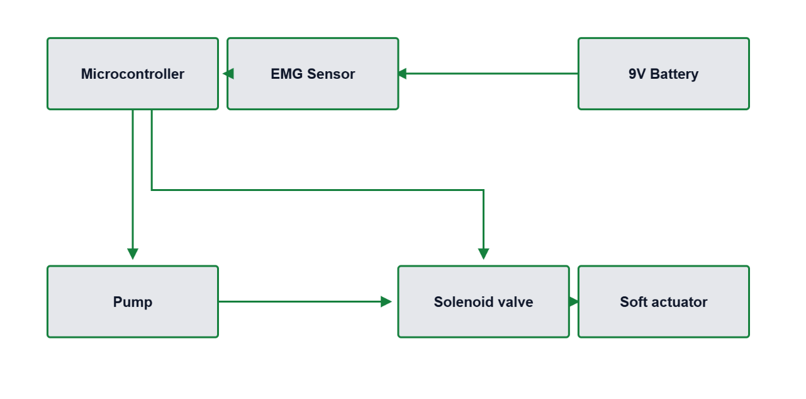
Figure 1: Block Diagram of Actuator
This block diagram Figure 1 represents the working of an EMG-based soft robotic actuator system, commonly used in rehabilitation devices for stroke recovery. The system is powered by a 9V battery, which supplies voltage to the EMG sensor. The EMG sensor detects electrical signals generated by muscle activity and sends these signals to the microcontroller. It directly activates the air pump, which generates air pressure needed to move the actuator. Simultaneously, the microcontroller sends a signal to transistors, which act as switches to control the solenoid valve. The solenoid valve, upon receiving the signal via the transistors, opens or closes to regulate the air flow towards the soft actuator. As a result, the soft actuator inflates or deflates depending on the air pressure, mimicking finger or hand movement. This system allows the robotic hand to respond to muscle activity, aiding in therapeutic or assistive movements.

3.3. Design Methodology
To create a functional prototype of our robotic hand, we took a step-by-step approach to engineering. The plan was to begin with determining what patients who have suffered from strokes require in their recovery process and then translate those requirements into a useful, functional system. Every component of the system was planned, constructed, and tested before progressing to the next phase. A step-by-step breakdown of the way we approached the design follows:

3.3.1. Requirement Analysis
Prior to constructing anything, we researched stroke rehabilitation and learned what existing assistive devices have to offer — and where they are lacking. From this, we determined a few important things our system had to do:
- The glove needed to be comfortable, light, and wearable for extended periods, so patients wouldn't tire or become irritated wearing it daily.
- The EMG sensing component had to be non-invasive (no pain or needles), but sensitive and consistent enough to pick up even slight muscle activity.
- The actuation system must be capable of replicating natural hand movement, particularly the flexing and extending of fingers.
- The system needs to provide real-time visual feedback to encourage users and allow them to see how they are doing.
- It needs to be safe, with regulated pressure so it doesn't injure the hand or lead to muscle fatigue.
- And lastly, it had to be affordable and easy to replicate, particularly for individuals in low-resource environments where high-tech medical devices are not available.
- These needs kept us focused on both technical functionality and user comfort and safety.

3.3.2. Soft Robotic Glove Module
The soft robotic glove operates as a light exoskeleton for the hand. Its primary function is to assist the user in bending (flexing) and straightening (extending) their fingers, particularly when they are unable to do so by themselves due to muscle weakness following a stroke.
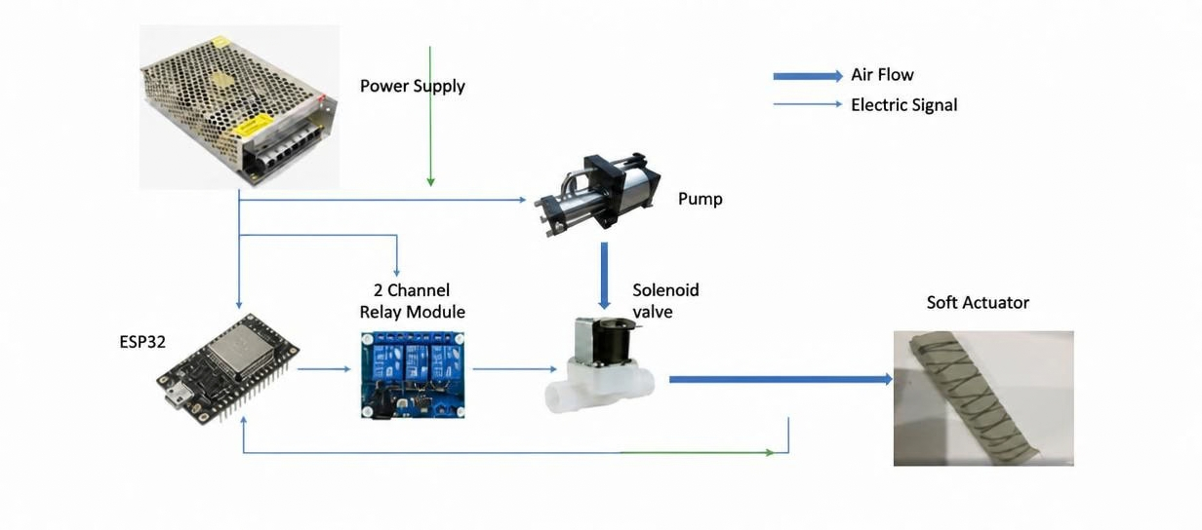
Figure 2: Working of Actuator

3.4. Working
Figure 2 shows the mechanical parts of the project and how they are working and connections to each other. The power supply is responsible for providing the necessary electrical power to all the components in the system, including the pump, solenoid valve, and relay module. It typically converts high-voltage AC power into a suitable DC voltage (such as 12V or 24V) required by the system.
The ESP32 serves as the brain of the circuit. Sends control signals to the relay module to operate different components like the pump and solenoid valve. The 2channel acts as an interface between the low-voltage logic of the esp32 and the highpower components. When the esp32 outputs a signal, the relay switches on the corresponding device, allowing high-current components like the pump or solenoid valve to operate safely.
The air pump generates compressed air and supplies it to the system. When turned on via the relay, it begins pumping air into the tubing system. This pressurized air is then directed to the solenoid valve, which controls the flow of air toward the actuator. The solenoid valve acts like a gatekeeper, allowing air to pass through when energized and blocking or releasing it when de-energized, depending on the control logic. The pressure sensor is installed downstream of the valve to monitor the level of air pressure being delivered to the actuator. It continuously sends feedback to the ESP32 so that it can regulate the pressure accurately to avoid over-inflation. Finally, the soft actuator responds to the controlled air pressure. It inflates or deflates accordingly, resulting in a bending or movement action like that of a finger or muscle. This makes the system suitable for soft robotics applications, such as hand rehabilitation or assistive movement.

3.4.1. Material and Structural Design
The foundation of the glove is constructed from a flexible and soft material such as neoprene or Lycra. The materials were used because they are elastic, breathable, and comfortable for extended use. On the top of the glove, over the back of every finger, we incorporated pneumatic channels — these are elastic air cavities that curve when filled up with air, softly flexing the fingers. These tubes were constructed from either TPE chambers or silicone tubes, both of which are resilient yet soft. If air is inflated into them, they expand and produce the motion required to enable the hand to close.

3.4.2. Pneumatic System
The pneumatic system that manages airflow to the glove consists of a few significant components:

a. Mini Air Pump
We employed a compact 5V diaphragm pump, capable of developing pressure (about 60–120 kPa) to fill the air chambers adequately. Figure 3 shows the mini air pumps which are used in this project, and they generate the pressure.
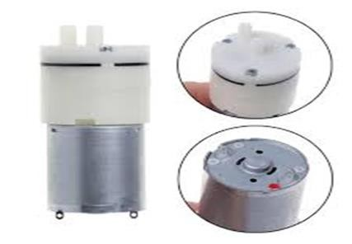
Figure 3: Mini Air Pump Generate the Pressure

b. Solenoid Valves
These are normally closed, 3-way (5V) valves. They open and close as directed by the microcontroller to allow air to enter or exit each finger chamber at the appropriate time.
Figure 4 shows the 3-ways solenoid valve. Which are used to control pressure.
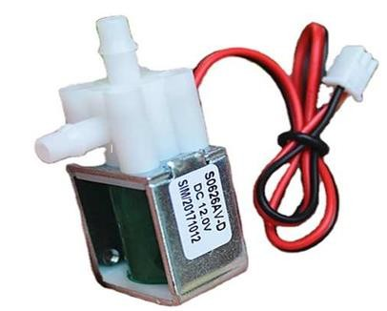
Figure 4: Solenoid Valve Control the Pressure

c. Pressure Control
To prevent damage to the glove or discomfort to the user, a pressure relief valve has been incorporated. This is a measure to ensure the glove is safe and does not get overinflated.

3.4.3. Actuation Logic
The glove is only triggered when the wearer attempts to move his or her hand, as measured by the EMG sensor. The microcontroller activates signals to open the solenoid valves and activate the pump. This fills air into the glove fingers, allowing them to bend. The air is permitted for a brief, controlled period (typically 5 to 10 seconds). Then the valves shut, and the air is vented, allowing the glove to return to its initial (relaxed) form, and returning the hand to a neutral position. This timing is critical — it simulates a natural grasp-and-release movement without over-stressing the hand.

3.5. Control Strategy
This project illustrates the working of a pneumatic-based soft actuator control system, commonly used in robotic rehabilitation applications. The system begins with a power supply unit that delivers electrical power to various components, including a pump, ESP32, and relay module. The ESP32 acts as the central controller, sending control signals to the 2-channel relay module, which in turn switches on or off highpower components like the pump and solenoid valve. When activated, the pump generates compressed air, which is directed through the solenoid valve. This valve, also controlled via the relay module, regulates the airflow towards the soft actuator.

3.6. Summary
This chapter detailed the design and methodology adopted for the EMG-based robotic hand. From sensor selection and thresholding to pneumatic actuation and control strategy, each subsystem was carefully engineered with the end-user in mind. The combination of real-time biofeedback with soft, adaptive actuation makes this system a promising solution for post-stroke hand rehabilitation. In the next chapter, the hardware implementation and testing results will be discussed, along with performance evaluation.

Chapter 4

Implementation & Testing

4.1. Introduction
The chapter describes how we physically constructed and linked our project's several elements: the EMG Based Robotic Hand meant to assist stroke sufferers in recovering the use of their hands. An EMG sensor module reads muscle signals from the forearm and displays muscle strength on a little screen, while a soft robotic glove helps move the patient's hand using air pressure.
Starting from each section autonomously to guarantee that they worked correctly, we started working. We combined the two parts to create a whole system once they had been verified. Particularly for individuals with limited hand movement following a stroke, we emphasized throughout the process simplicity, cost, and ease of use. The chapter goes through the creation of each component as well as how everything was linked together to function as one useful rehabilitation tool.

4.2. Implementation of the Soft Robotic Glove Module
Also called actuator, there are air chambers within the glove. These compartments generate finger motion. Filled with air, they expand and bend the fingers. The fingers relax and the chambers return to their natural forms when the air is let out. This basic inflate and deflate motion mimics natural hand motions by itself. It is a useful way to help the user to practice finger movements without stressing their muscles.

4.2.1. Pneumatic System Setup
To control the air movement, we built a basic pneumatic system made up of:
- Mini air pumps that create the airflow needed to fill the chambers.
- Manual valves that control the air supply to each finger.
- Flexible plastic tubes carry the air from the pumps to the glove.
- An ESP32 microcontroller, which is used in other parts of the system, but does not control the valves in this module.

4.2.2. Individual Finger Control
The glove has a manual valve for each finger, thereby controlling airflow in needed direction to that finger. Air enters the appropriate chamber and bends the finger by opening a valve manually. Shutting the valve and opening the air lets the finger return to its starting position.
Testing and first usage are made more versatile by this manual control. Though not automatic, it nonetheless complements the fundamental stroke recovery physiotherapy exercises.

4.3. Implementation of the EMG Sensor Module
A noninvasive EMG sensor like the MyoWare sensor is used to keep everything simple to use and secure. Such a sensor is unobtrusive, resting above the skin and not needing body insertion, therefore it is inside. For instance, when someone attempts to close their hand, the sensor can identify electric signals that occur normally when muscles contract.
Following parts cooperate to give the module:

4.3.1. EMG Sensor
Located on the forearm, the EMG sensor detects the little electrical signals produced by the muscle. Figure 5 shows the EMG module sensors which detect the signal from the muscles.
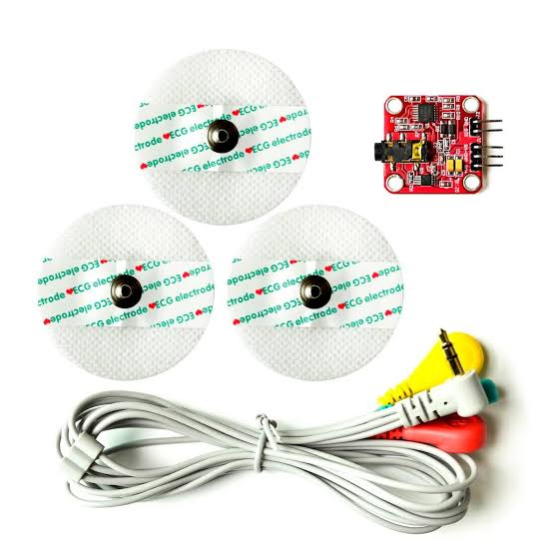
Figure 5: EMG Sensor Module Kit

4.3.2. A microcontroller (ESP32)
This serves as the system's brain. It gets the sensor signals, analyses them, and organizes the data. Figure 6 shows the microcontroller ESP3 which are the brain of this project.
They control all the signals.
Figure 6:Esp32 Microcontroler

4.3.3. LCD Display
On the small screen, the muscle signal magnitude is shown in real time. Figure 7 shows the LCD which are used in this project for the showing of the EMG sensor value.
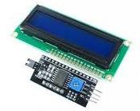
Figure 7: LCD Display the EMG Sensor Value

4.3.4. Module's Operation
The sensor is typically placed over the forearm muscle group that controls hand and finger motion to operate the EMG module. The muscle contracts and produces an electrical signal when the subject attempts to move their hand or clench their fist. Since the sensor first magnifies (boosts) this signal and filters it to get rid of noise or unwanted data, it is rather modest.
Once cleaned up, the signal goes to the esp32. The signal is processed by the ESP32, which also estimates its amplitude. The LCD screen then displays the strength level either as a bar graph (to visually represent muscle activity) or as a numerical value (as with a score). Even if the hand is not yet moving, this enables the therapist and the patient to observe how much muscle activity is occurring.

4.4. Integration of Both Modules

4.4.1. System Integration
The next stage was to combine them and cause them to operate as a single, cohesive system once both the soft robotic glove and the EMG sensor module were running well by themselves. Since it enabled both modules to interact and operate stably for live stroke rehabilitation, this integration was a very vital aspect of the project.

4.4.2. Connecting Muscle Signals to Glove Movement
Integration started by establishing a communication channel between the microcontroller (ESP32) and the EMG sensor. The EMG sensor transmits an electrical pulse from the forearm muscle activity it registers to the ESP32. Reading this signal, the ESP32 determines whether the person wishes to move their hand. Should the muscle signal be powerful enough, the ESP32 transmits an order to signal the soft robotic hand. Figure 8 shows the use of the EMG sensor on the muscles.
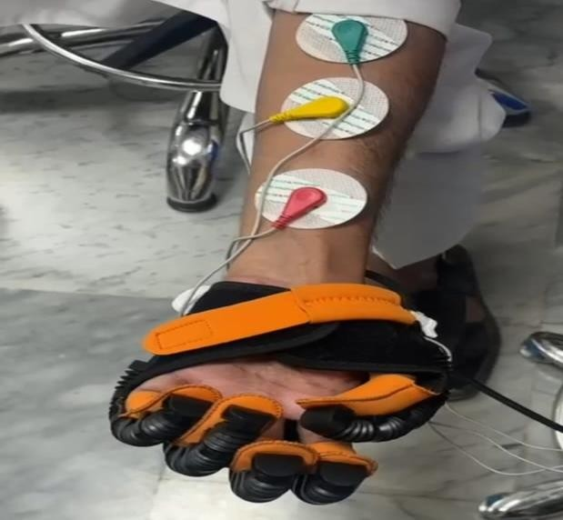
Figure 8: Using EMG Sensor Module

4.4.3. Making the System Move in Sync with Muscle Activity
One of the objectives of this mechanism was to generate natural feeling motions. Therefore, we ensured that the soft glove's finger motions are accurately timed with the muscle activity of the patient. This type of synchronization allows the patient to feel more attuned to the movement, which might improve physical therapy's efficiency. Just as a genuine hand, the glove flexes the fingers simultaneously with their muscle contraction and relaxes.

4.4.4. Displaying Feedback for the User
We included an LCD screen showing the muscle signal power in real time to help the user stay active and knowledgeable. The screen displays a difference right away as the user tries to move their hand. Although their hands doesn't yet completely move, this comment is basic but quite useful since it inspires the patient and informs them that their efforts are acknowledged.
It also lets therapists check the patient's development. In Figure 9 shows the EMG sensor values and Modes on the screen.
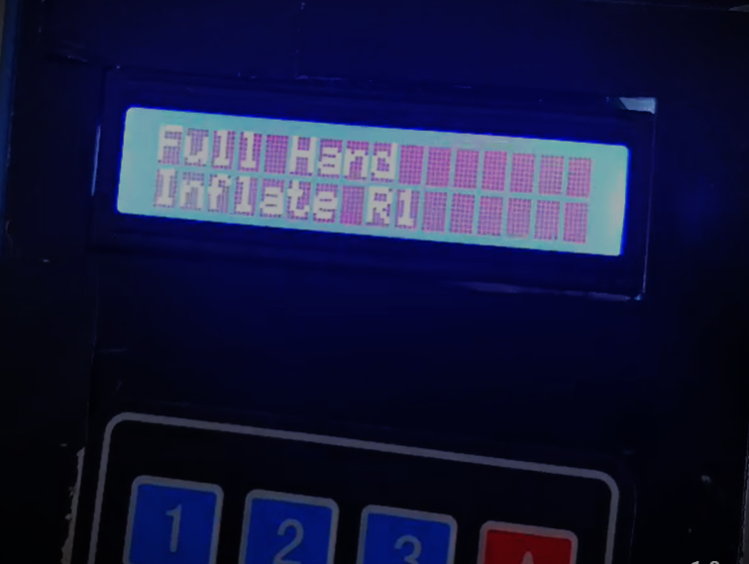
Figure 9: Showing the Value of the EMG Sensor on LCD

Live Dashboard on Web
This is showing the live dashboard using to control the simple and user easly use and lot of think.
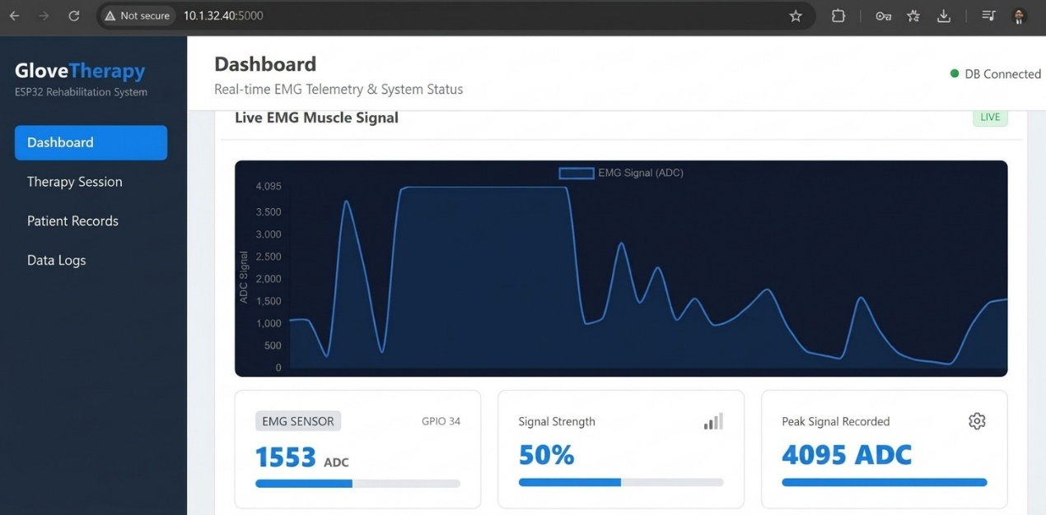

4.5. Summary
The development and incorporation of the EMG-based robotic hand system are covered in this chapter. Every module was thoughtfully developed and tested; then, they were combined to work harmoniously. The outcome is a straightforward, inexpensive, and efficient remedy helping stroke victims in their hand recovery path.

Chapter 5

Results and Discussion

5.1. Introduction
In this chapter, we will take you through the result we have obtained after creating and experimenting with our EMG-based soft robotic hand. It can help stroke patients recover hand movement during their rehabilitation. We subjected the system to extensive performance testing in several key areas—how fast it responds when it detects muscle signals, how accurately it moves the hand, how comfortable it is to wear, and how user-friendly it is overall. We also subjected the system to testing for how good it is at giving the user feedback, such as displaying EMG signal strength on an LCD display.
Along the way, we combined the two primary components of our project:
- The air-pressure-driven soft robotic glove, and
- The EMG sensor module that senses muscle activity from the user. Lastly, we will also mention some of the problems that we faced while developing and testing the system and how we overcame them to increase the performance of the system.

5.2. Performance of the Soft Robotic Glove
The soft robotic glove was developed to support finger movement by a pneumatic actuation system. Testing of the glove proved its capability to execute finger flexion (bending) and extension (straightening) motions. The motions were executed using controlled inflation and deflation of specially designed silicone air chambers integrated into the glove. When air was injected into the chambers, they inflated and bent their fingers. After the release of air, the fingers went back to their resting position.
The inflation and deflation cycle were smooth and timely, generating a movement that closely resembled the natural motion of the human hand. Solenoid valves regulated the pneumatic system, directing the flow of air in and out of the chambers. The valves were fast to respond to control signals from the microcontroller, allowing for a repeatable and consistent actuation cycle. The system's responsiveness was essential in providing a glove that could help finger movement in real time, and this was especially necessary for rehabilitation applications.

5.3.Key Observations

5.3.1. Comfort and Fit
The glove was determined to be lightweight and pliable. It accommodated various hand sizes, providing comfort to a wide range of users. This aspect is particularly crucial in the case.

5.3.2. Ease of Use:
The use of Velcro straps made it easy for users to put on and take off the glove without needing help. This enhances the usability of the glove in home-based rehabilitation environments.

5.3.3. Responsive Actuation:
In test conditions, the inflation of the air chambers took place in a period ranging from 1 to 2 seconds, a response time that is quite acceptable for such systems. Deflation happened virtually instantly when valves were switched, thus enabling the glove to shift to its base state and ready itself for the next movement cycle.
Although these were favorable outcomes, there were challenges faced, especially in the testing process during the early stages. One of the major issues was air leakage in the silicone chambers. This issue decreased the efficiency of the glove's movement and slowed down the inflation process. Upon inspection, it was discovered that the leaks were caused by insufficient sealing of the chambers and loose tube connections.
To address this, the silicone chambers were reinforced with a second layer of sealant around the seams to become airtight. In addition, the interfaces between the air tubes and solenoid valves were tightened and secured by clamps and glue to avoid disconnection or leakage when operational. Once these solutions were in place, the system displayed great improvement in performance and reliability.
In general, the soft robotic glove module worked well and achieved its design requirements. It exhibited smooth and controlled movement, ease of operation, and an effective fit, which made it appropriately suited for use in rehabilitations of stroke patients, who might have weak or sensitive hands.

5.4.EMG Signal Aquisition
Some signal acquisition difficulties did occur. Occasionally the readings were unstable, primarily due to inadequate skin contact with the electrodes or muscle fatigue after extended use. These issues were resolved by taking extra care to properly position the electrodes for good contact with the skin. Signal filtering methods were also utilized to eliminate extraneous noise and enhance the quality of the signal from the muscle activity.

5.5. Control Strategy Evaluation
After both the soft robotic glove and the EMG sensor module were tested in isolation, the task then became integrating both into one system. Integrating them created a closed-loop control system, where the movement of the glove relied directly on the muscle signals of the user, which were picked up by the EMG sensor.
Control over the solenoid valves and the control algorithm was implemented via an Arduino microcontroller, which executed the algorithm. The algorithm constantly compared the EMG signal and adjusted the inflation and deflation of the glove's air chambers accordingly by controlling the opening and closing of the solenoid valves. There was no delay observed in the control process and response of the glove compared to the user's muscle activation. This fast response time is crucial to the natural and responsive rehabilitation experience.
Another advantage of the system design was its modularity. Both components, the EMG module and the glove module, could be debugged and tested in isolation before integrating them. This simplified debugging and ensured each component worked optimally in isolation.
In general, the combined closed-loop system was able to effectively couple the user's bio-signals to the robotic support offered by the glove. Such direct interaction is a primary characteristic for motor relearning when it comes to stroke rehabilitation, as it promotes active engagement and enables retraining the brain and muscles to restore hand function.

5.6.User Feedback and Comfort
While official clinical trials have not yet taken place, preliminary informal testing was performed with healthy volunteers to obtain preliminary feedback on how comfortable and easy to use the glove is. This preliminary testing was useful in learning how the device feels and functions while being used.
The users mostly found the glove to be very comfortable. Since the glove is constructed of soft materials and fitted to be comfortable without feeling too tight, it did not induce any discomfort or fatigue even for short use. This is significant as if the glove were uncomfortable, the users would be less inclined to wear it frequently, and this would impact rehabilitation.
The pneumatic inflation pressure was also well-adjusted. It was powerful enough to flex the fingers well, mimicking native hand movements, yet not so powerful that it produced pain or discomfort of any kind. This is important because the intention is to help move gently, facilitate muscle relearning without forcing it.
Another favorable feature pointed out by the users was the feedback presented on the LCD screen. The visual real-time feedback, in the form of numerical values, was easy to interpret and served to keep the users motivated. Having the ability to observe their muscle activity and effort levels provided users with a sense of control and progress, which can be motivational for rehabilitation.
Overall, these initial observations indicate that the glove design is comfortable and easy to use. With a bit more development and testing in clinical settings, it could be wellaccepted by stroke patients who are undergoing rehabilitation.

5.7. Discussion of Limitations
Although the EMG-based soft robotic hand prototype has demonstrated very encouraging results, there are currently some significant limitations that need to be overcome in future research.
First, the system is presently only semi-portable. This is to say that while the glove itself is light and easy to control the pneumatic pump and ancillary hardware are still relatively cumbersome and not so portable. For real-world use on a daily basis, particularly for stroke patients who might wish to utilize the device in the home or even outside clinics, the pump and control system must be miniaturized and reduced in size. Miniaturization of the parts would significantly enhance the device's overall portability and ease of use.
Second, the glove is designed mainly to assist with basic hand movements, specifically finger bending (flexion) and straightening (extension). While this helps with larger motions needed for grasping or releasing objects, the glove currently cannot assist with more delicate and precise hand movements—often called fine motor controls such as pinching, rotating fingers, or manipulating small objects. Generation of these more subtle movements is vital for complete hand function and will necessitate more sophisticated mechanical design and control strategies in the future.
Although this serves well in laboratory conditions, it may fail under real-world conditions when there is excessive movement or electrical interference. For instance, if the user is creating a lot of movement in their arm or if the sensor positioning is not optimal, the signals will become less sharp and lead to the system reacting inaccurately or missing some muscle activations. Developing the system so that it better handles EMG signals—maybe through the application of more sophisticated filtering mechanisms or machine learning technologies—will be needed to make it more accurate and robust for day-to-day use.

5.8. Summary
The glove was thus able to act virtually instantaneously, producing a smooth and natural motion that simulated actual hand movement.
Users would be able to watch their muscle signals appear on an LCD screen, providing another level of feedback and interaction.
Though the system is not perfect yet and there is still room for improvement, like how fast it could be, how small, or even how comfortable, it is nonetheless encouraging. They demonstrate that this type of configuration could indeed be feasible and helpful in aiding stroke patients in rehabilitation. It demonstrates that controlling a soft robotic glove through EMG signals is more than an idea, it's an effective and viable solution to aid genuine recovery.

Chapter 6

Conclusion and Future Work

6.1. Conclusion
This project effectively designed and developed a soft robotic hand that assists patients in the recovery of hand movement. The system primarily involves two components:
- A soft robotic glove that operates the fingers through air pressure (pneumatics).
- An EMG sensor module that senses muscular activity from the user's forearm.
The soft glove was constructed with silicone air chambers that expand and contract. When air was blown into the chambers, the glove flexed the fingers naturally. When the air was let out, the fingers would return to their normal position. This motion was easy and mimicked that of real fingers. The glove was light, soft, and would comfortably fit varying hand sizes.
Air pressure control was maintained by an Arduino microcontroller and solenoid valves. The valves rapidly routed the air in and out of the glove, providing fast and responsive finger motion according to received signals.
The EMG (Electromyography) sensor module was utilized to capture muscle activity from the user's forearm. When the user attempted to move his hand, the muscles produced electrical signals. The sensor detected these signals and transmitted them to the microcontroller. The information was also displayed on an LCD display; hence users could view their muscle strength and effort in real time. This visual feedback assisted users in comprehending and enhancing their muscle control.
One important element of this system was that the we have used the EMG sensor module which measures the strength of the muscles. This implies that the glove would not move unless the user attempted to move their hand. This "closed loop" control system made the therapy more useful because it got the user actively engaged in the rehabilitation process rather than completely passive.
Even though we did not carry out formal medical testing, the device was experimented on with healthy users. They indicated that the glove was:
- Tolerable to wear.
- Did not lead to pain or tiredness 3) when used for a short time.
4) The LCD feedback was beneficial and clear.
These are positive feedback, indicating that the device is user-friendly and has potential for application in stroke rehabilitation in the future.

6.2. Project Limitations
Although the project was able to accomplish its main objectives, some crucial limitations remain that should be addressed in future iterations of the device. These limitations concern how practical, functional, and user-friendly the system is within actual real-world applications, particularly for extended use on the part of stroke patients. The following are the primary areas where improvements should be made:

6.2.1. Probability
The biggest issue with the prototype so far is its lack of portability. While the glove itself is light and comfortable to wear, supporting elements—particularly the pneumatic pump, air supply system, and control hardware—are still considerably bulky. These components are presently mounted on a table or adjacent platform and need external power and support. This configuration restricts user mobility and renders the device less convenient to use outside of a lab or clinical setting.
For patients suffering from stroke and who might prefer to do rehabilitation exercises at home or on the move, it is necessary to make the whole system more portable and self-contained. This involves redesigning the pneumatic system and electronics so that they are smaller in size, lighter, and potentially battery-powered so that the device can be worn and used without being tethered to large external components.

6.2.2. Limited Range of Motion
Another shortcoming of the existing glove is that it can only accommodate simple hand movements, namely, finger flexion (bending) and extension (straightening). Though basic, these movements are not sufficient to accomplish more intricate actions based on fine motor skills, like grasping small objects, turning a key, or buttoning a shirt. These are common movements that trouble many stroke patients, so their facilitation is equally critical as the restoration of basic hand motion.
- To make the glove more useful, future models need to be designed to provide more sophisticated movement, including:
- Individual control of each finger (as opposed to all fingers moving at once).
- Thumb opposition (thumb touching other fingers).
Lateral or circular hand movements providing additional controls and more flexibility for the glove would enable patients to practice a greater range of actual activities during therapy.

6.2.3. Basic EMG Signal Processing
In rehabilitation or robotic systems, such as a soft robotic hand, the processed EMG signal is sent to a microcontroller (like esp32), which interprets the muscle activity as a command. Based on this, the system can trigger actuators or pumps to move a robotic limb or finger, allowing muscle intentions to translate into actual movement— facilitating motor recovery and assistance for stroke patients.

6.3. Future Work
Although the present iteration of the EMG-controlled soft robotic hand has yielded exciting results, there are numerous possibilities for enhancing and broadening the system to make it more functional, user-friendly, and efficient for actual rehabilitation. Some of the most important areas that can be targeted in further development are as follows:

6.3.1. Miniaturization and Enhanced Portability
One of the main improvements planned for the next version of the device is to make it smaller, lighter, and easier to carry. Right now, the prototype still depends on bulky equipment like a big air pump and connecting wires, which makes it hard for stroke patients to use on their own, especially at home or in public places. To fix this, we can use smaller and quieter pumps that can be worn on a belt or in a backpack. We can also switch to rechargeable batteries so the system can work without wires. Another idea is to replace the air-based system with different technologies like shape memory alloys, twisted string actuators, or soft artificial muscles. These methods don’t need air pressure or tubes and can make the device much lighter. Making the whole system more compact and wireless would make it more comfortable to wear and easier for patients to use during daily activities, whether at home or out and about.

6.3.2. Precise Control for Fingers
Currently, the glove helps with only basic finger flexion and extension, with all fingers acting at once. Yet in real life, human beings operate their hands with much greater specificity and coordination—like pinching, picking up fine objects, or operating individual fingers.
Future work should focus on adding more advanced and user-friendly features to improve the functionality and rehabilitation potential of the glove. One key area is individual finger control, which would allow each finger to move independently, enabling more natural and precise hand movements. Another important feature is the inclusion of different grip types, such as power grip, pinch grip, or tripod grip, which can be programmed into the system. These preset modes would help patients practice real-life tasks more effectively. Additionally, the glove should be able to adapt its motion based on the strength or duration of the EMG signals, providing customized assistance that matches the user's needs. Incorporating these features would significantly improve the glove’s usefulness in rehabilitation by helping patients regain control over fine motor skills that are essential for everyday activities.

6.3.3. Future Enhancements in EMG Signal Processing
The present system employs straightforward signal processing through EMG sensor. The EMG sensor only takes the value from the muscles and then shows on the LCD. Using sophisticated digital filtering methods, such as Butterworth or Kalman filters, can successfully remove noise from the original EMG signals to enhance signal purity. Adaptive thresholding enables the system to learn and adapt threshold values in realtime based on the user's condition to increase responsiveness accuracy. Furthermore, incorporating machine learning models to identify patterns of muscle activation would allow the glove to learn more complex user intent and minimize false activations.
Combined, these improvements would make the device more intelligent and sensitive, greatly enhancing its safety, accuracy, and user confidence.

6.3.4. Clinical Testing and Validation
To date, the system has only been tested in an informal manner on healthy people. To make sure that it helps stroke patients, formal clinical trials need to be conducted. These trials would consist of:
- Testing the glove on real stroke patients under close supervision.
- Estimating recovery in motor function over periods of time.
- Collecting structured feedback from patients, therapists, and physicians.
Clinical trials will assist in the identification of practical problems not evident through laboratory testing, including comfort when used over extended periods, ease of use by individuals with disabilities, and actual therapeutic effects. This input will inform significant design and control system improvements.
Moreover, collaboration with rehab professionals will ensure the device accommodates best practice therapy methods.

6.3.5. User Interface Improvements
The existing LCD screen only offers simple visual feedback such as bar graphs or numbers representing muscle effort. Although useful, there can be scope for an interactive and interactive interface to encourage users during the rehabilitation process. Possible improvements in the future could be:
Creating a mobile application that wireless communicates with the glove would enable users to monitor their progress, get exercise suggestions, and personalize their therapy. The application can offer graphical representations of improvement over the course of time that can be easily sent to therapists for effective monitoring. To address the issue of making therapy more interactive, exercises may be made into easy-to-play games that provide encouragement particularly for younger patients or individuals who need encouragement. For another, integrating voice guidance or sound prompts would enable users to do the movements correctly and remind them of any inappropriate actions.
Generally, a more interactive and user-friendly interface would bring about greater user satisfaction and promote frequent use, which is essential for successful rehabilitation.

6.4. Summary
This work has established a solid basis for an assistive hand rehabilitation device that can respond to muscle signals from humans and deliver mechanical assistance to regain hand motion. For the device to be practical for extensive, real-world use, future innovations should aim at developing a more portable and wearable system, allowing precise and coordinated hand motions, and integrating intelligent processing methods to enhance signal detection. In addition, clinical trials must be conducted to confirm the efficacy of the device, and more interactive and user-friendly interface is required. These changes will not only increase the therapeutic benefits but also move the technology toward practical application for stroke recovery patients.

6.5. Final Remarks
This project provides a good basis for a novel and user-friendly assistive device to aid stroke rehabilitation. Although there are still some technical issues to resolve, the encouraging initial findings indicate the potential advantages of integrating EMG-based control with soft robotic technology. With further development and testing, this prototype can become a useful tool for enhancing the quality of life for patients with stroke.

References
- https://www.thelancet.com/journals/lancet/article/PIIS0140-6736(24)014430/fulltext
- https://doi.org/10.3390/app12094540
- https://electrobes.com/product/emg-muscle-signal-sensor-module-kit-forarduino/
- Zhou, M.; Wang, H.; Zeng, X.; Yin, P.; Zhu, J.; Chen, W.; Li, X.; Wang, L.; Wang, L.; Liu, Y.; et al. Mortality, morbidity, and risk factors in China and its provinces, 1990–2017: A systematic analysis for the Global Burden of Disease Study 2017. Lancet 2019, 394, 1145–1158.
- GBD 2019 Stroke Collaborators. Global, regional, and national burden of stroke and its risk factors, 1990–2019: A systematic analysis for the Global Burden of Disease Study 2019. Lancet Neurol. 2021, 20, 795–820.
- Owolabi, M.O.; Thrift, A.G.; Mahal, A.; Ishida, M.; Martins, S.; Johnson, W.D.; Pandian, J.; Abd-Allah, F.; Yaria, J.; Phan, H.T. Primary stroke prevention worldwide: Translating evidence into action. Lancet Public Health 2021, 7, e74–e85.
- Feigin, V.L.; Brainin, M.; Norrving, B.; Martins, S.; Sacco, R.L.; Hacke, W.; Fisher, M.; Pandian, J.; Lindsay, P. World Stroke Organization (WSO): Global Stroke Fact Sheet 2022. Int. J. Stroke 2022, 17, 18–29.
- Cassidy, J.M.; Mark, J.I.; Cramer, S.C. Functional connectivity drives stroke recovery: Shifting the paradigm from correlation to causation. Brain 2021, awab469.
- Kim, S.; Lee, J.; Bae, J. Analysis of Finger Muscular Forces using a Wearable Hand Exoskeleton System. J. Bionic Eng. 2017, 14, 680–691.
- Kim, S.; Lee, J.; Park, W.; Bae, J. Quantitative Evaluation of Hand Functions using a Wearable Hand Exoskeleton System. In Proceedings of the 2017 International Conference on Rehabilitation Robotics (ICORR), London, UK, 17–20 July 2017.
- Bortoletto, R.; Mello, A.N.; Piovesan, D. A springs actuated finger exoskeleton: From mechanical design to spring variables evaluation. In Proceedings of the 2017 International Conference on Rehabilitation Robotics (ICORR), London, UK, 17–20 July 2017; Volume 2017, pp. 1319–1325.
- Decker, M.; Kim, Y. A Hand Exoskeleton Device for Robot Assisted SensoryMotor Training after Stroke. In Proceedings of the 2017 IEEE World Haptics Conference (WHC), Munich, Germany, 6–9 June 2017.
- Jo, I.; Lee, J.; Park, Y.; Bae, J. Design of a wearable hand exoskeleton for exercising flexion/extension of the fingers. In Proceedings of the 2017 International Conference on Rehabilitation Robotics (ICORR), London, UK, 17–20 July 2017; Volume 2017, pp. 1615–1620.
- Sale, P.; Stellin, G.; Masiero, S.; Becchi, F.; Sieklicki, W. FEX a Fingers Extending eXoskeleton for Rehabilitation and Regaining Mobility; Springer: Cham, Switzerland, 2018.
- Zhang, F.; Hua, L.; Fu, Y.; Chen, H.; Wang, S. Design and development of a hand exoskeleton for rehabilitation of hand injuries. Mech. Mach. Theory 2014, 73, 103–116.
- In, H.; Kang, B.B.; Sin, M.; Cho, K.-J. Exo-Glove: A Wearable Robot for the
Hand with a Soft Tendon Routing System. IEEE Robot. Autom. Mag. 2015, 22, 97– 105.
- In, H.; Jeong, U.; Lee, H.; Cho, K.J. A Novel Slack-Enabling Tendon Drive That Improves Efficiency, Size, and Safety in Soft Wearable Robots. IEEE/ASME Trans. Mechatron. 2017, 22, 59–70.
- Jeong, U.; In, H.; Lee, H.; Kang, B.B.; Cho, K.J. Investigation on the control strategy of soft wearable robotic hand with slack enabling tendon actuator. In Proceedings of the 2015 IEEE International Conference on Robotics & Automation (ICRA), Seattle, WA, USA, 26–30 May 2015; pp. 5004–5009.
- Yap, H.K.; Lim, J.H.; Goh, J.C.H.; Yeow, C.-H. Design of a Soft Robotic Glove for Hand Rehabilitation of Stroke Patients With Clenched Fist Deformity Using Inflatable Plastic Actuators. J. Med. Devices 2016, 10, 044504.
- Hsu, T.-H.; Chiang, Y.-C.; Chan, W.-T.; Chen, S.-J. A Finger Exoskeleton Robot for Finger Movement Rehabilitation. Inventions 2017, 2, 12.

